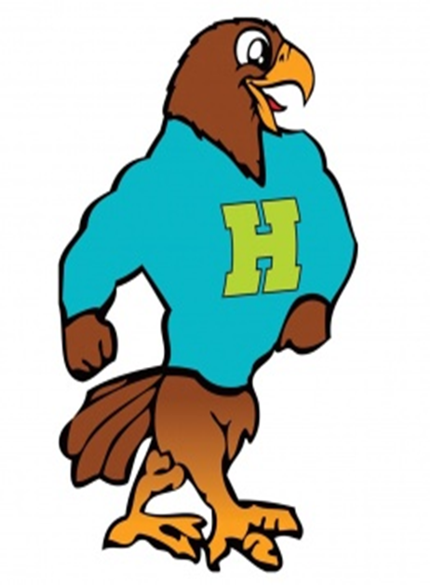

**Herbert Akins Road Elementary**

**1st Grade Supply List 2024 - 2025**

|  |  |  |
| --- | --- | --- |
| Item | Amount Needed | Notes |
| * Scissors | 1 |  |
| Zip pencil pouch | 1 | No boxes please |
| Crayola Crayons 24 count | 1 box |  |
| Glue sticks | 6 | NO SCENTED PLEASE |
| Pencils | 2 packs | Ticonderoga pre-sharpened pencils are preferred. Please no colorful or printed pencils. |
| 2 Plastic folders with pockets and prongs | 1 yellow & 1 blue | Please do not label with names. |
| Primary Journal | 1 | The journal with a picture box and lines at the bottom. |
| Large Pink Eraser | 3 |  |
| Black dry erase markers | 2 packs | No colors please |
| Pair of personal headphones | 1 |  |
| Tissues | 2 Boxes |  |
| Paper Towels | 1 Roll |  |
| **Girls:** Clorox Wipes and 1 Box of Gallon Ziploc Bags | 1 of each |  |
| **Boys**: Clorox wipes and 1 Box of Sandwich Ziploc | 1 of each |  |

**\*\*Individual teachers may request additional supplies to support learning in their classroom. Please check in with your teacher at our Meet the Teacher event in July. Feel free to bring supplies to the Meet the Teacher event.**